Software Project Management Plan

for

TMC Entrance Examination Answer Sheet Recognition and Scoring System

List of Figures

Figure No. Description Page
Figure 1.0 External Structure 13
Figure 2.0 Internal Structure 14
Figure 3.0 Feature Breakdown Structure 15

List of Tables
Table No. | Description | Page
Table 1.0 | Milestone Task | 10
Table 2.0 | Definition, Acronyms, and Abbreviations | 11
Table 3.0 | Roles and Responsibilities | 14
Table 4.0 | Staff and Person Involved in Project | 16
Table 5.0 | Work Plan | 18
Table 6.0 | Work Activities | 23
Table 7.0 | Methods and Techniques | 28
Table 8.0 | Tools | 28

Overview

The TMC Entrance Examination Answer Sheet Recognition and Scoring System is an intelligent solution designed to modernize the evaluation process for entrance exams at Trinidad Municipal College (TMC). By integrating Optical Mark Recognition (OMR) and computer vision, the system automates the detection and scoring of multiple-choice answer sheets. This addresses the significant time and accuracy challenges associated with manual checking, providing a faster and more reliable process for the Admissions Office.

Project Summary

Project Rationale

The TMC Entrance Examination Answer Sheet Recognition and Scoring System is proposed to improve the process of checking multiple-choice entrance examination answer sheets at Trinidad Municipal College (TMC). Manual checking requires exam personnel to identify marked responses, compare them with an answer key, and calculate scores, which can become time-consuming when processing numerous answer sheets. Previous studies have demonstrated that automated Optical Mark Recognition (OMR) can significantly reduce the time required for answer-sheet processing while providing reliable recognition results [1], [2].
The system will consist of a mobile application for capturing and scanning answer sheets and a web-based administrative platform for managing answer keys, examination records, and results. The mobile component is supported by research demonstrating the feasibility of using smartphone-captured images for automated answer processing, although image conditions such as camera angle, paper position, and image distortion must be considered [3].
The system will integrate Computer Vision and Optical Mark Recognition (OMR) to identify shaded responses from captured answer sheets. Research on OMR-based assessment has shown that image-processing techniques can recognize marked responses and automate the collection or evaluation of answer-sheet data [1], [4]. After recognition, the system will compare the detected responses with the official answer key and automatically compute the applicant's score.
The proposed system therefore focuses on reducing repetitive manual checking, improving consistency in answer recognition and scoring, and providing an organized process for examination evaluation. The web-based component will allow authorized personnel to manage and review examination information, while the mobile application will support the initial scanning and recognition of answer sheets.
Statement of the Problem

The problems that led the proponents to propose the TMC Entrance Examination Answer Sheet Recognition and Scoring System are as follows:
- Time-Consuming Manual Checking: Manually checking multiple-choice answer sheets requires personnel to inspect marked responses, compare them with the answer key, and calculate scores. Studies on automated answer-sheet evaluation identify time reduction as a major motivation for implementing OMR-based grading [1], [2].
- Difficulty in Processing Scanned or Captured Answer Sheets: Images captured using mobile devices may be affected by camera angle, paper position, lighting, and distortion, which can make answer-area detection more challenging [3]. Therefore, the system needs to process captured answer-sheet images before recognizing the marked responses.
- Recognition of Shaded Responses: Determining which option has been marked for each examination item is a critical part of automated answer-sheet checking. OMR and computer-vision techniques have been used to detect and interpret marked responses from answer sheets [1], [4].
- Human Error in Checking and Scoring: Manual examination checking can be affected by fatigue and human error, particularly when large numbers of answer sheets are evaluated. Recent research on OMR-based assessment identifies these issues as challenges that automated evaluation can help address [2].
- Manual Score Computation: After determining the applicant's answers, personnel must compare the responses with the official answer key and calculate the final score. An automated checking process can perform this comparison and score computation systematically.
- Need for an Integrated Scanning and Administrative Process: A mobile application can provide a practical means of capturing answer-sheet images, while a web-based platform can provide authorized personnel with a centralized environment for managing answer keys, recognized responses, scores, and examination records. Integrating these components can create a continuous workflow from scanning and answer recognition to checking, scoring, and record management.

1.1.1. Purpose, Scope and Objectives
Purpose
The TMC Entrance Examination Answer Sheet Recognition and Scoring System is an intelligent solution designed to automate the evaluation of entrance examination answer sheets at Trinidad Municipal College (TMC). The system utilizes artificial intelligence and machine learning to recognize shaded responses from scanned multiple-choice answer sheets, automatically compute examination scores, and securely store the results in a centralized database. It also enables administrators to efficiently manage applicant records, answer keys, and examination results.
Scope
The scope of this project encompasses the design, development, testing, and deployment of the TMC Entrance Examination Answer Sheet Recognition and Scoring System. The system will provide the following features required by the target users:

Admissions Office Personnel / Administrators
- System Management: Create and manage user accounts, roles, and system-wide configurations.
- Answer Key Management: Create and edit answer keys for examinations.
- Dashboard: View overview of applicants, total examinations conducted, passing statistics, and recent activities.
Entrance Examination Staff
- AI-Based Answer Sheet Recognition: Scan uploaded answer sheets and utilize AI-powered Optical Mark Recognition (OMR) for automatic answer detection.
- Score Computation: Automatically compute examination scores with instant pass/fail determination.
- Result Management: View and manage examination results.
- Mobile Access: Scan answer sheets using the phone camera.
Objectives
The primary objectives of the TMC Entrance Examination Answer Sheet Recognition and Scoring System project are:
- Automate Answer Sheet Processing: Develop and integrate an AI-powered module that automates the recognition and digitization of student responses from scanned multiple-choice answer sheets, reducing processing time by at least 70% compared to manual methods.
- Increase Scoring Accuracy: Eliminate human error in score computation by using a robust digital scoring engine, ensuring 100% accuracy in score calculation.
- Accelerate Result Release: Significantly reduce the turnaround time for releasing examination results to applicants from days to minutes.
- Improve Data Security and Integrity: Securely store all examination records in a centralized, auditable database with role-based access control.

1.1.2. Assumptions and Constraints
The TMC Entrance Examination Answer Sheet Recognition and Scoring System is designed as a full-stack examination management ecosystem with AI capabilities. Therefore, the system will be built using the following technologies:
- Front-end (Web): React.js
- Mobile Application: React Native (Android)
- Back-end (API & Server): Laravel (PHP)
- AI/ML Model: Python with PyTorch; Flowise; Optical Mark Recognition (OMR)
- Database: MySQL
- Additional Tools: RESTful APIs, Docker, Nginx, Git/GitHub
Assumptions
- The TMC Admissions Office will provide physical answer sheets that can be scanned using Android phone cameras or document scanners in a standard digital format (JPEG, PNG) of sufficient quality for AI-based Optical Mark Recognition.
- The format of the physical answer sheets will be standardized and known during the development phase for proper AI/OMR model training.
- Staff will have access to Android smartphones with cameras capable of capturing clear images of physical answer sheets.
- Intended users will have basic computer literacy and mobile device proficiency, and will be receptive to training.
- The system will comply with the Data Privacy Act of 2012 (Republic Act No. 10173).

Constraints
- Time: The project must be completed within the academic semester schedule.
- The total budget is strictly limited to ₱5,000, which will cover: Web hosting and domain, AI/ML infrastructure costs, and Miscellaneous.
- Technology Stack: Development is strictly constrained to React.js (Web), React Native (Android), Laravel, Python/PyTorch, and MySQL.
- Data Privacy: The system must comply with all relevant data privacy regulations.
- Performance: The AI processing module must handle a batch of answer sheets (100-200 per session) within a reasonable timeframe.
- Platform: The mobile application is specifically designed for Android only; iOS is out of scope.

1.1.3. Project Deliverables

The following is a list of the major deliverables for the TMC Entrance Examination Answer Sheet Recognition and Scoring System project:
- Software Documentation (Software Engineering Docs)
- Software Project Management Plan (SPMP)
- Software Requirements Specification (SRS)
- Software Design Document (SDD)
- Software Test Document (STD)
- Software Program (TMC Entrance Examination Answer Sheet Recognition and Scoring System)
- Functional web and mobile application with core features
- AI Model Training Report
- Installation of software program on target hardware
- User manual

1.1.4. Schedule and Project Summary

This is the schedule summary of the project. On the other hand, no budget was provided during the conduct of the study.

Milestone Task | Date Started | Completion Date
Project Title Proposal | July 13, 2026 | July 24, 2026
Data Gathering | August 10, 2026 | August 21, 2026
Development Phase I | October 5, 2026 | November 20, 2026
Software Test I | November 21, 2026 | November 27, 2026
Development Phase II | November 30, 2026 | December 18, 2026
Software Test II | December 19, 2026 | December 23, 2026
Development Phase III | January 4, 2027 | January 22, 2027
Software Test III | January 23, 2027 | January 31, 2027

Table 1.0 Milestone Task

Evolution of Plan

The Project Manager must first approve all modifications to the project management plan before they can be carried out. In order to keep the project management plan accurate and current, all modifications should be documented and version-controlled.

Definition, Acronyms, and Abbreviations

Terms | Definition
AI | Artificial Intelligence- The simulation of human intelligence processes by computer systems, specifically used for recognizing and interpreting data from scanned documents.
Android | A mobile operating system developed by Google, used for the mobile application in this project.
Computer Vision (CV) | A field of AI that enables computers to derive meaningful information from digital images, videos, and other visual inputs.
OMR | Optical Mark Recognition - The technology used to detect the presence or absence of a mark on a scanned image.
RA 10173 | Republic Act No. 10173, also known as the Data Privacy Act of 2012.
SPMP | Software Project Management Plan
SRS | Software Requirements Specification
SDD | Software Design Document
STD | Software Test Document
TMC | Trinidad Municipal College - The client and target institution for this project.

Table 2.0 Definition, Acronyms, and Abbreviations

References

[1] J. Muangprathub, O. Shichim, Y. Jaroensuk, and S. Kajornkasirat, (2018). “Automatic Grading of Scanned Multiple Choice Answer Sheets,” International Journal of Engineering and Technology, vol. 7, no. 2. Available at: https://doi.org/10.14419/ijet.v7i2.23.11910
[2] C. Han, A. Krishna K., P. V., M. Castro, et al., (2025). “A Study and Implementation of Customizable Optical Mark Recognition Sheets for Assessments,” 2025 IEEE Frontiers in Education Conference (FIE). Available at: https://doi.org/10.1109/FIE63693.2025.11328230
[3] X. Li, T. Yue, X. Huang, Z. Yang, and G. Xu, (2019). “BAGS: An Automatic Homework Grading System Using the Pictures Taken by Smart Phones,” arXiv. Available at: https://arxiv.org/abs/1906.03767
[4] T. D. Quy, P. T. T. Nga, and N. V. H. Dung, (2021). “Application of Optical Mark Recognition Techniques to Survey Answer Sheets at Dalat University,” Dalat University Journal of Science, vol. 11, no. 1, pp. 93–103. Available at: https://doi.org/10.37569/DalatUniversity.11.1.791
[5] Y. Hernández-Mier, M. A. Nuño-Maganda, S. Polanco-Martagón, G. Acosta-Villarreal, and R. Posada-Gómez, (2025). “Unsupervised Optical Mark Recognition on Answer Sheets for Massive Printed Multiple-Choice Tests,” Journal of Imaging, vol. 11, no. 9, p. 308. Available at: https://doi.org/10.3390/jimaging11090308

Project Organization

This clause of the SPMP identifies the interfaces to organizational entities external to the project, describes the project's internal organizational structure, and defines the roles and responsibilities for the project.

External Structure

The TMC Entrance Examination Answer Sheet Recognition and Scoring System is developed for Trinidad Municipal College (TMC). It will be utilized primarily by the Admissions Office personnel and entrance examination staff. The organizational chart of the external structure is presented below.
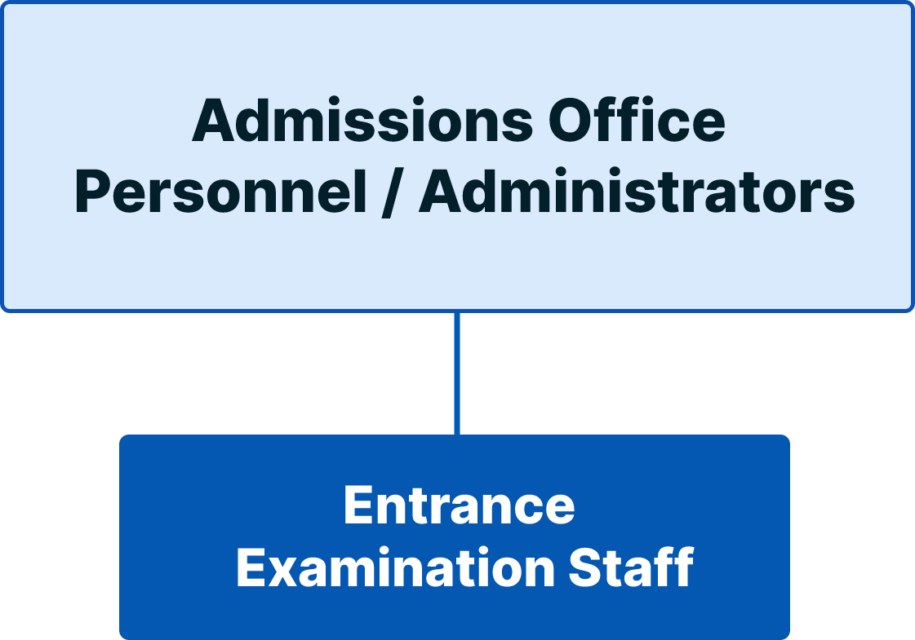

Figure 1.0 External Structure

Internal Structure

The TMC Entrance Examination Answer Sheet Recognition and Scoring System project is composed of a dedicated development team with clearly defined roles: Project Manager, Lead Developer/Programmer, Tester, Documentation Lead, and System Analyst. The lines of authority and communication of the aforementioned units are depicted in Figure 2.
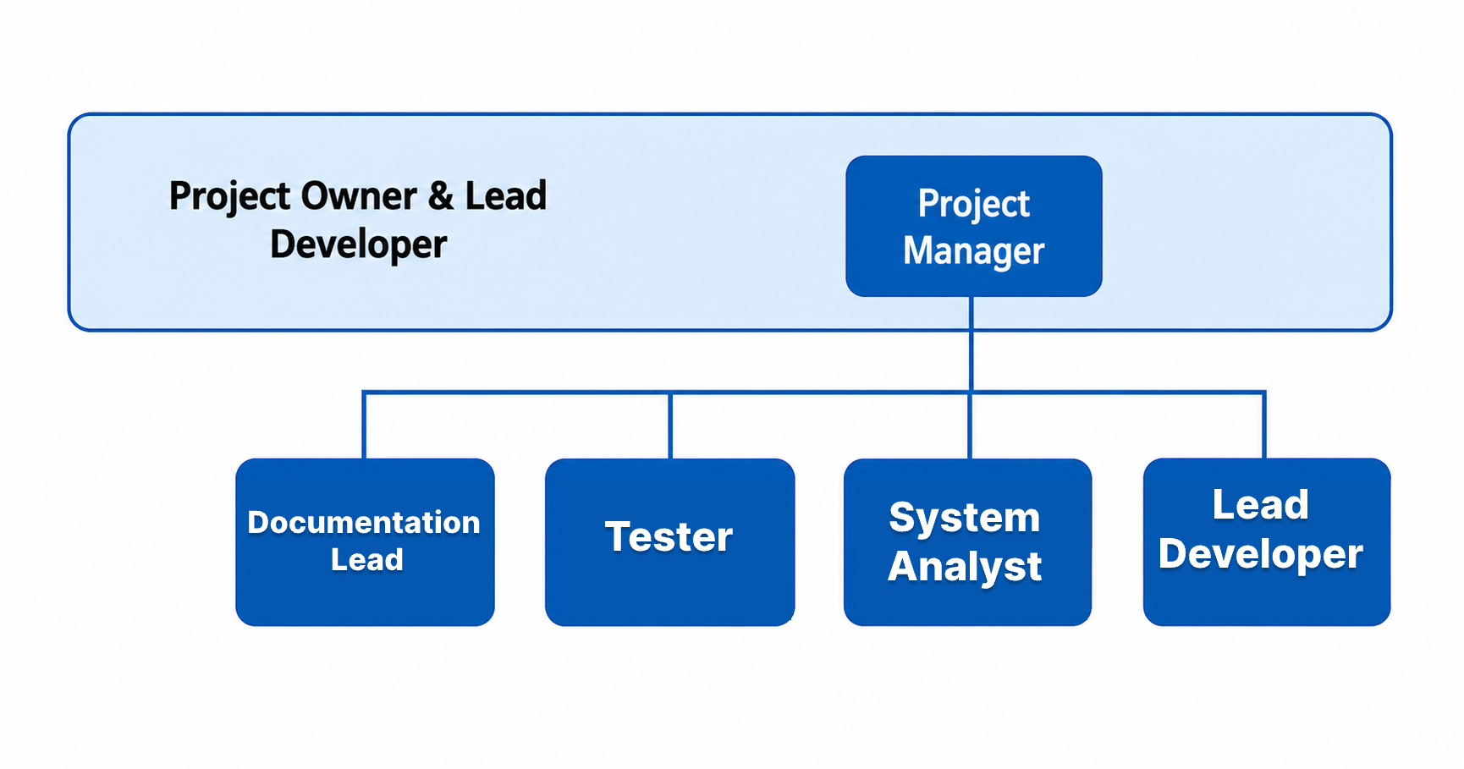

Figure 2.0 Internal Structure

Roles and Responsibilities

This section of the document describes the role and responsibilities for each member in the project team involved in delivering the TMC Entrance Examination Answer Sheet Recognition and Scoring System software requirement.
Role | Responsibilities
Project Manager | Plan, execute, and monitor all project activities. Manage schedule, scope, and risks. Communicate project status to stakeholders. Lead the project team.
Lead Developer/ Programmer | Develop web (React.js) and mobile (React Native) applications. Develop Laravel backend and RESTful APIs. Design database schema. Develop and integrate AI/ML module (Python/PyTorch). Deploy the system.
System Analyst | Conduct requirements gathering and analysis. Create system design specifications and diagrams. Ensure system design meets user needs.
Tester | Create test plans and test cases. Perform functional, integration, and system testing. Document and track bugs. Coordinate User Acceptance Testing (UAT).
Documentation Lead | Create and maintain all project documentation. Prepare SPMP, SRS, STD, and user manuals. Compile final deliverables.

Table 3.0 Roles and Responsibilities

Managerial Process Plans

This clause of the SPMP specifies the project management processes for the project. This clause shall be consistent with the statement of project scope and shall include the project start-up plan, work plan, control plan, and project closeout plan.

Start-up Plan

This clause of the SPMP specifies the estimation, staffing, resources acquisition, and project staff training plan.

3.1.1. Estimation Plan

The proponents will be using an Agile Software Development methodology since the nature of requirements defined by the user is dynamic. Constraints and rules are bound to change in the middle of the development and even after the deployment of the project. The development will be divided into three iterations but might expand if there are additional changes after these iterations.
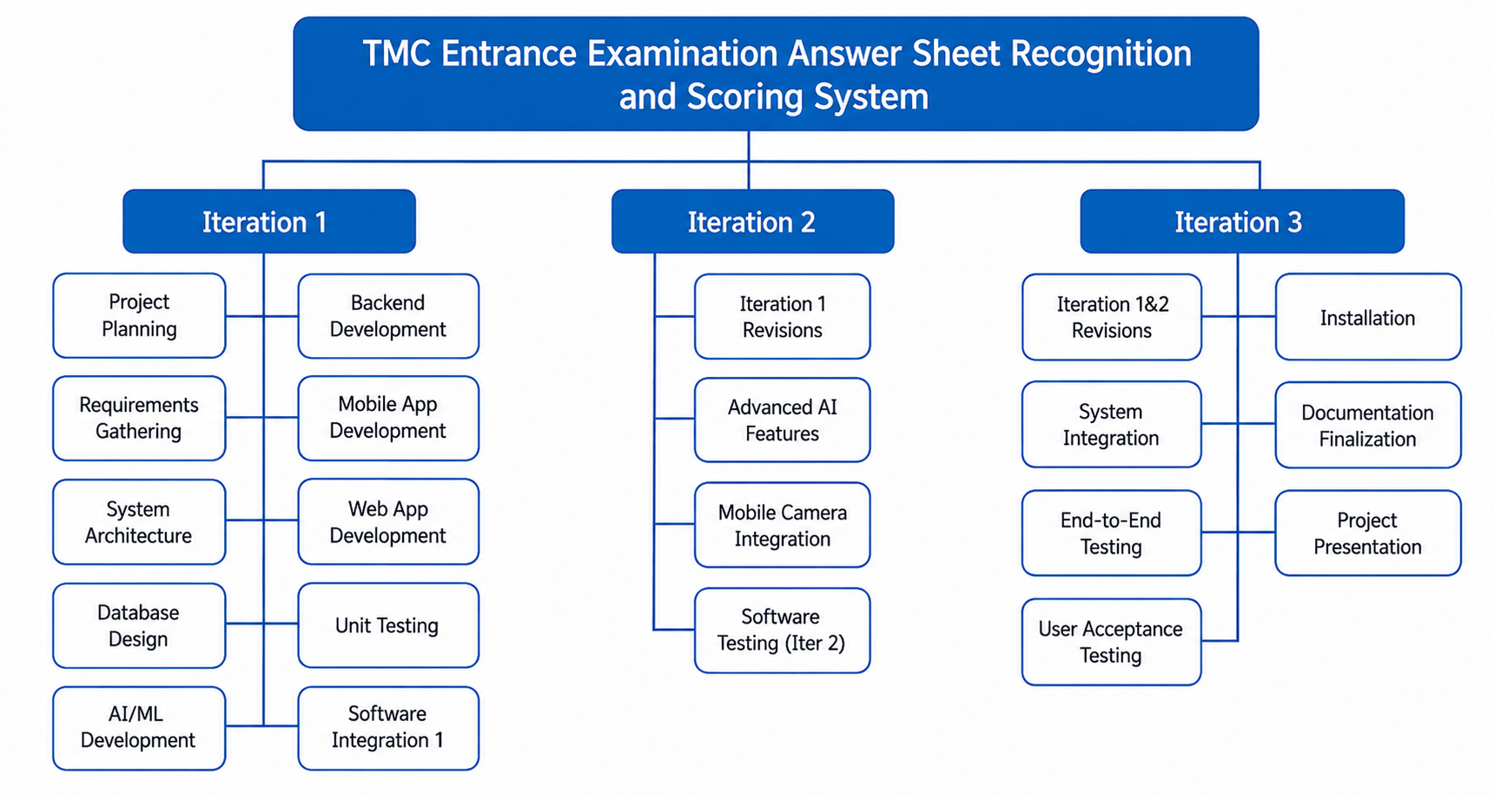

Figure 3.0 Feature Breakdown Structure

3.1.2. Staffing Plan

The table below shows the team members involved in the TMC Entrance Examination Answer Sheet Recognition and Scoring System project.

Name | Position | Status
Faye Marie B. Busalanan | Project Manager | Full Time
James Carl B. Enquig | Lead Developer/Programmer | Full Time
John Paul C. Amistad | Tester | Full Time
Honeylet A. Montoya | Documentation Lead | Full Time
Pedro S. Aclo | System Analyst | Full Time

Table 4.0 Staff and Person Involved in Project

3.1.3. Resource Acquisition Plan

All necessary hardware, software, and tools for the project are already available to the proponents. For requirements needed to gather, the project team will provide request letters to the TMC Admissions Office to access information regarding the current examination process and answer sheet formats. The proponents will conduct formal and informal interviews and list all necessary requirements for the development of the system.

3.1.4. Project Staffing Plan
No formal training for the project participants will be needed. The project team is already well-trained and has experience in their respective areas of expertise. However, the following informal training and knowledge sharing activities will be conducted:
- AI/ML Module Training: The Lead Developer will provide an overview of the OMR system to the team.
- Technology Stack Orientation: A brief session on the integration points between React.js, React Native, Laravel, and Python.
- End-User Training: The project team will conduct an orientation session for the TMC Admissions Office personnel on how to use the system effectively.

Work Plan

This section describes in detail the decomposition of the total scope of work of the TMC Entrance Examination Answer Sheet Recognition and Scoring System project to be carried out by the project team to accomplish the project objectives and create the required deliverables.

Project Task | Estimated Schedule
1 Iteration 1
1.1 Project Planning and Requirements Gathering | October 5 – 9, 2026
1.2 System Architecture Design | October 12 – 16, 2026
1.3 Database Design and Setup | October 13 – 16, 2026
1.4 AI/ML Model Development (OMR Engine) | October 19 – 30, 2026
1.5 Laravel Backend Development (Core APIs) | October 19 – 30, 2026
1.6 React Native Mobile App Development | October 26 – November 6, 2026
1.7 React.js Web App Development | October 26 – November 6, 2026
1.8 Module Integration | November 9 – 20, 2026
1.9 Software Testing (Iteration 1) | November 21 – 27, 2026
2 Iteration 2
2.1 Iteration 1 Revisions | November 30 – December 4, 2026
2.2 Advanced AI Features (Batch Processing, Optimization) | November 30 – December 11, 2026
2.3 Mobile Camera Integration for Scanning | December 7 – 18, 2026
2.4 Software Testing (Iteration 2) | December 19 – 23, 2026
3 Iteration 3
3.1 Iteration 1 and 2 Revisions | January 4 – 8, 2027
3.2 System Integration and End-to-End Testing | January 4 – 15, 2027
3.3 User Acceptance Testing (UAT) | January 11 – 15, 2027
3.4 Deployment and Installation | January 11 – 22, 2027
3.5 User Training and Documentation Finalization | January 18 – 22, 2027
3.6 Software Testing (Iteration 3) | January 23 – 31, 2027

Table 5.0 Work Plan

3.2.1. Work Activities

The work activity table specifies the different tasks per iteration. It also shows the person assigned to the task and the estimated labor hours allotted for each activity.

Project Task | Role | Labor Hours
1 Iteration 1
1.1 Project Planning and Requirements Gathering |  | 52
Requirements Gathering (Interviews, Meetings) | System Analyst, Project Manager | 18
Requirements Analysis and Documentation | System Analyst | 24
Project Plan Finalization | Project Manager | 10
1.2 System Architecture Design |  | 32
Kick-off Meeting | Project Manager | 2
System Design and Modeling | System Analyst, Lead Developer | 18
Architecture Review | Project Manager, Lead Developer | 6
Technical Specifications Documentation | Lead Developer | 6
1.3 Database Design and Setup |  | 24
Database Schema Design | Lead Developer | 12
Database Setup and Configuration | Lead Developer | 6
Data Modeling Review | System Analyst | 6
1.4 AI/ML Model Development (OMR Engine) |  | 96
Kick-off Meeting | Project Manager | 2
Image Preprocessing Module | Lead Developer | 26
Shaded Response Detection Model | Lead Developer | 30
Score Computation and Answer Key Matching | Lead Developer | 26
AI Model Testing and Validation | Lead Developer, Tester | 14
1.5 Laravel Backend Development (Core APIs) |  | 40
Kick-off Meeting | Project Manager | 2
API Design and Documentation | Lead Developer | 12
User Authentication and Authorization APIs | Lead Developer | 18
Answer Key Management APIs | Lead Developer | 10
1.6 React Native Mobile App Development |  | 50
Mobile App UI/UX Design | Lead Developer | 12
Answer Sheet Scanning Module (Basic) | Lead Developer | 20
Result Viewing Module | Lead Developer | 12
Notification Module | Lead Developer | 6
1.7 React.js Web App Development |  | 50
Web App UI/UX Design | Lead Developer | 12
User Management Module | Lead Developer | 10
Answer Key Management Module | Lead Developer | 10
System Configuration Module | Lead Developer | 6
Initial Dashboard Layout | Lead Developer | 6
1.8 Module Integration |  | 36
Unit Testing (All Modules) | Lead Developer, Tester | 20
Module Integration | Lead Developer | 16
1.9 Software Testing (Iteration 1) |  | 24
Kick-off Meeting | Project Manager | 2
Test Case Creation | Tester | 8
Functional Testing | Tester | 8
Bug Reporting and Documentation | Tester | 6
2 Iteration 2
2.1 Iteration 1 Revisions |  | 46
Bug Fixes and Improvements | Lead Developer | 30
Code Review | Lead Developer | 8
Regression Testing | Tester | 8
2.2 Advanced AI Features |  | 64
Batch Processing Implementation | Lead Developer | 24
AI Performance Optimization | Lead Developer | 24
Accuracy Enhancement | Lead Developer | 16
2.3 Mobile Camera Integration for Scanning |  | 32
Camera API Integration | Lead Developer | 16
Image Capture and Upload Module | Lead Developer | 16
2.4 Software Testing (Iteration 2) |  | 32
Integration Testing | Tester | 16
Performance Testing | Tester | 8
Bug Reporting and Documentation | Tester | 8
3 Iteration 3
3.1 Iteration 1 and 2 Revisions |  | 48
Kick-off Meeting | Project Manager | 2
Bug Fixes and Improvements | Lead Developer | 30
Code Review and Refactoring | Lead Developer | 8
Regression Testing | Tester | 8
3.2 System Integration and End-to-End Testing |  | 56
End-to-End Testing | Tester | 24
Security Testing | Tester | 16
User Experience Testing | Tester | 8
Bug Reporting and Documentation | Tester | 8
3.3 User Acceptance Testing (UAT) |  | 32
UAT Preparation and Coordination | Project Manager | 8
UAT Execution | Tester, End-Users | 16
UAT Feedback and Revisions | Lead Developer | 8
3.4 Deployment and Installation |  | 32
XAMPP Local Deployment | Lead Developer | 8
Production Server Deployment | Lead Developer | 16
System Configuration and Setup | Lead Developer | 8
3.5 User Training and Documentation Finalization |  | 56
User Manual and Administrator Manual | Documentation Lead | 24
Mobile Application User Guide | Documentation Lead | 16
End-User Training Session | Documentation Lead, Lead Developer | 16
3.6 Project Presentation and Final Deliverables |  | 48
Project Presentation Preparation | Project Manager, Documentation Lead | 24
Final Deliverables Compilation | Documentation Lead | 16
Final Presentation Preparation | All Team Members | 8
GRAND TOTAL |  | 846

Table 6.0 Work Activities

3.2.2. Schedule Allocation

The project duration is constrained to three different iterations. Each iteration is allocated with different numbers of working hours due to different tasks for every iteration. However, the schedule presented may change depending on the modifications of the requirements of the user.

3.2.3. Resource Allocation

The development team has a fixed amount of time available for the project. The whole development period is divided into three iterations. Thus, the development team is given 400 hours for the first iteration, 174 hours for the second iteration, and 272 hours for the third iteration to comply with the requirements and tasks assigned to them.

3.2.4. Budget Allocation

The project is funded entirely by the proponents through their allocated capstone project budget, with a total limit of ₱5,000. The budget may be allocated for:
- Web Hosting & Domain
- AI Integration Cost (Backup/Contingency)
- Miscellaneous

Control Plan

This sub-clause of the SPMP specifies the metrics, reporting mechanisms, and control procedures necessary to measure, report, and control the product requirements, the project schedule, budget, and resources, and the quality of work processes and work products. All elements of the control plan should be consistent with the organization's standards, policies, and procedures for project control as well as with any contractual agreements for project control.

3.3.1. Requirements Control Plan

Requirement will be managed in use case description of SRS as requirements are changed.

3.3.2. Schedule Control Plan

The development team will conduct daily stand-up meetings to monitor daily progress. The Project Manager will supervise the meeting. Every member of the team must identify their progress, impediments, and the task they plan to accomplish the next day. In this way, the whole team knows the status of every developer. Moreover, they can learn from the different impediments mentioned by the other developers. The Project Manager will provide a weekly status report to the TMC Project Adviser to keep them informed of progress. After each iteration, the team will conduct a retrospection meeting to evaluate performance and identify areas for improvement.

3.3.3. Budget Control Plan

The project budget will be strictly monitored to ensure all expenditures remain within the ₱5,000 limit. The Project Manager will oversee budget tracking and approval for all expenses.

3.3.4. Quality Control Plan

The tester will generate a separate Software Testing Document. From this document,
checklists and other evaluation measures will be determined necessary or otherwise. Unit testing will be the main mechanisms of the development team to control the quality of the work process and the resulting work. More detailed plan is presented at Software Testing Document.

3.3.5. Reporting Plan

The team will submit a report to the TMC Project Adviser every end of the iteration to provide updates on the progress of development. During the development, the team will have daily stand-up meetings which will serve as their report and updates for the accomplished tasks.

3.3.6. Metrics Collection Plan

As mentioned in the schedule control plan, daily stand-up meetings will be held to track the progress and impediments of every member. A retrospection meeting will also be conducted after every iteration to evaluate team performance.

3.3.7. Risk Management Plan

Risks will be identified at the beginning of each phase, and the Project Manager will assemble them into a prioritized risks list. During the daily stand-up meeting, the team members will raise risks and reassess the prioritized risks. Team members will determine mitigation plans for all identified risks and tasks that need to be completed, and then these risks and tasks will be assigned as action items. The team will monitor high-priority risks every week, and all risks will be documented by the team. The major risks identified for this project include the AI/OMR model failing to accurately recognize shaded responses, which will be mitigated through extensive training with diverse answer sheet samples and an iterative improvement approach with a fallback manual verification option. Data privacy and security concerns will be addressed by ensuring compliance with the Data Privacy Act of 2012, implementing role-based access control, and using data encryption.

3.3.8. Project Closeout Plan

The development team will ensure the proper closeout of the project by April 2, 2027 (Submission of Hard Bound). Final deliverables will be submitted, the system will be deployed, and the Project Acceptance Form will be signed by the authorized representative of Trinidad Municipal College(Dr. Julie T. Maestrado).

Technical Process Plans

This clause of the SPMP shall specify the development process model, the technical methods, tools, and techniques to be used to develop the various work products; plans for establishing and maintaining the project infrastructure; and the product acceptance plan.

Process Model

An agile project management methodology or framework used primarily for software development projects with the goal of delivering new software capability. The development will be divided into three iterations but might expand if there are additional changes after these iterations.

Methods, Tools, and Technique

The methods and techniques listed in this table will be evaluated and applied in specific areas of the project as appropriate:
Category | Methods and Techniques
Requirements Elicitation | Meetings, Interviews, Document Analysis, Brainstorming
Formal Specification and Analysis | Formal models using UML to model structural aspects of the requirements and Design; Use cases to define requirements
Prototyping | Paper prototypes, Interactive prototypes
Development Methodology | Agile Methodology
Testing | Unit Testing, Integration Testing, System Testing, User Acceptance Testing
AI/ML Development | Iterative model training, Cross-validation, Performance optimization
Version Control | Git branching strategy, Feature branching, Pull request reviews

Table 7.0 Methods and Techniques

Category | Tools
Operating System | Windows 10/11, Ubuntu 20.04+
Mobile Development | React Native (Android)
Front-end Framework | React.js (Web)
Back-end Framework | Laravel (PHP)
Database | MySQL
AI/ML Development | Python, PyTorch, Flowise, Optical Mark Recognition (OMR), OpenCV
Diagrams/Modeling | Lucidchart, Draw.io, Figma
Version Control | Git/GitHub
IDE/Code Editor | Visual Studio Code
Documentation | Microsoft Word, Google Docs, WPS Office
Additional Tools | RESTful APIs

Table 8.0 Tools

Infrastructure Plan
The TMC Entrance Examination Answer Sheet Recognition and Scoring System is designed as a full-stack examination management ecosystem with AI capabilities. The system will be built using the following technologies: Operating System: Windows 10/11, Ubuntu 20.04+, React.js for web front-end, React Native for Android mobile application, Laravel (PHP) for backend API and server, Python with PyTorch and Flowise for AI/ML model with Optical Mark Recognition (OMR), MySQL for database, and additional tools such as RESTful APIs, Docker, Nginx, and Git/GitHub.
The system is accessible through modern web browsers and Android mobile devices. The system requires an active internet connection for operation. The mobile application will be distributed through standard app deployment channels (APK installation).

Product Acceptance Plan

A representative from the client (Trinidad Municipal College Administration, represented by Dr. Julie T. Maestrado) will be presented with a Project Acceptance Form. The in-charge personnel of the proposed project will sign this form as proof of accepting the final deliverable following successful User Acceptance Testing (UAT). The Project Title Approval Form has already been reviewed and approved by Clark Kevin V. Villamor, the Project Title Reviewer.

Supporting Process Plans

This clause of the SPMP contains plans for the supporting processes that span the duration of the software project. These plans include, but are not limited to, verification and validation, software documentation, quality assurance, and problem resolution. Plans for supporting processes shall be developed to a level of detail consistent with the other clauses and sub-clauses of the SPMP. In particular, the roles, responsibilities, authorities, schedule, budgets, resource requirements, risk factors, and work products for each supporting process shall be specified. The nature and types of supporting processes required may vary from project to project; however, the absence of a configuration management plan, verification and validation plan, quality assurance plan, joint acquirer-supplier review plan, problem resolution plan, or subcontractor management plan shall be explicitly justified in any SPMP that does not include them. Plans for supporting processes may be incorporated directly into the SPMP or incorporated by reference to other plans.

Verification and Validation Plan

The development team has created a separate Software Testing Document for the verification and validation.

Documentation Plan

There are a number of documents that will be produced during the lifetime of the project. All documents are responsibility of the project team members. The lists of documents that will be created and maintained under version control include:
- Software Project Management Plan (SPMP)
- Software Requirements Specification (SRS)
- Software Testing Document (STD)
- Software Design Description (SDD)
- User Manual / System Documentation
- Project Title Approval Form

Quality Assurance Plan

To ensure the quality of product, results from software test document shall be evaluated to distinguish all problems encountered. Problems found shall be fixed then.

Problem Resolution Plan

Any major problem faced by the development team should be discussed during the
daily stand up meeting. Decisions are to be finalized by the project manager.

